Leak Detector
Operation Manual
This product uses heated semi-conductor gas sensor, which is suitable for the detection of all halogen refrigerants. Active induced draft sampling system is used to provide airflow of the same direction for the probe, and the response speed is faster. Built-in Lithium batteries can be charged through Micro-USB, so it is more convenient to be carried and operated anywhere.
Operation Instructions
- Measure the refrigerant leakage according to instruction and within the scope of the parameters specified in manual.
- Do not clean the instrument with corrosive detergent or solvent.
- Wear goggles and protective gloves.
- Due to built-in heated semi-conductor gas sensor inside instrument,Do not operate in high-concentration flammable and explosive gas environment
- Service life of Sensor≥1 year under normal operation. If work in high-concentration environment for a long time,which will drain the life of sensor quickly, Please replace the sensors as soon as possible when the sensor doesn’t work.
Product Description
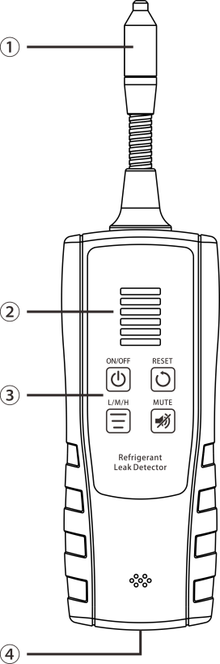
① | Semi-conductor gas sensor
② | Leakage concentration indicator
③ | Power button ON/OFF: Power on and off, button LED,red light,yellow light and green light indicate high battery level, medium battery level,low battery level respectively.
③ | Zero setting button RESET: Ignore the refrigerant concentration around the probe
③ | Sensitivity L/M/H: button LED,green light,yellow light,red light indicate L (Low) M(Medium) and H(High) sensitivity respectively
③ | Mute button MUTE: The button LED is off in silent mode;red light indicate non-silence mode.
④ | Mini-USB charging interface

Technical Parameter
Available refrigerant | CFC, HCFC and HFC refrigerants
Minimum detectable leakage rate | ≤ 3g/year (R134a)
Response time | ≤ 3 seconds (depending on the size of leak source and distance to the leak source)
Life time of sensor | ≥ 1 year under normal operation
Length of probe | 40 cm flexible probe/ feeler lever
Lithium battery | 2000 mAh (standby time: about 8 hours)
Charging parameters | 5V 1A, charging time: about 4-5 hours, Micron-USB interface
Operating temperature | 0-40℃（32-104℉）

Basic Operations

Power on/off
- Press the power button ON/OFF ,after a sound "beep",the sensor begin to preheat,After 60S, you will hear a sound "beep,beep",which means that the sensor have finished preheating and measure has begin.
Note: It is necessary to turn on the instrument to preheat the sensor in clean air.
- Press the power button ON/OFF again to shut down instrument.
Environment Reset
- Press the reset button RESET, after a sound “beep”, sensor begins to reset,button LED indicate red light,concentration indicator begins to flicker, after 60s,When the concentration indicator and button LED is off,which means that it has finished one time of environmental reset operation.
- This function is to ignore the concentration of refrigerant in the surrounding environment, to avoid continues cousto-optic alarm and interference detection in the environment with a certain concentration of refrigerant.
- After turn on the leak detector,the instrument finish one time of environment reset automatically by default, and the concentration of refrigerant around the probe is automatically ignored.
Note: In order to ensure the accuracy of leak detector, It is necessary to turn on the instrument to preheat the sensor in clean air.
Sensitivity setting
The leak detector provides three-level of sensitivity, default:High sensitivity,sensitivity could be switched in order L/M/H level.
Note: Under the high sensitivity, the leak detector is very sensitive. Some changes in temperature and pressure of the surrounding air may trigger the alarm.
Leakage indication
When leakage occurs, the leak indicator will display the concentration from level 1 to level 6 according to the concentration change, and the alarm make the warning beep in different frequency from level 1 to level 6.
Automatic power off
Automatic power off after 10 minutes without any key operation.
Charging mode
- Connect the leak detector with Micro-USB for charging,The ON/OFF button LED indicate yellow light,which says it’s charging;ON/OFF button LED indicate green light,which says it’s fully charged.After remove the Micro-USB from the leak detector, ON/OFF button LED,red light,yellow light and green light indicate high battery level, medium battery level,low battery level respectively.
- Under power on,when connect the leak detector with Micro-USB for charging,the concentration indicator begins to flicker,Two concentration indicator flicker,which means low battery level,Four concentration indicator flicker,which means medium battery level,Six concentration indicator flicker,which means high battery level,then after 2 seconds,indicator shutdown.Leak detector enter into measure mode.
Battery indicator
Long press mute button MUTE to check the battery level through flickering indicator, the flickering indicator means that the instrument is under battery charging period, After fully charged,it will stop flickering.
Caution:
- Don't wait for the battery to be recharged at low power level, try your best to recharge as often as possible in order to prolong the service life of the battery.
- When the battery is fully charged, please remove the charger in time to avoid charging too long time,otherwise,there may be some damages to battery.
- Do not charge at ambient temperature above 40℃ or under direct sunlight, otherwise the battery may be damaged.
Leak positioning
Slowly move the probe through the area where leakage may occur. If leakage is detected, the leak detector starts to alarm. With the increase of refrigerant concentration, the frequency of acoustic and optical alarm accelerates. If the leak source is identified, the leak source can be located accurately by slowly approaching the leak source from all directions of the non-alarm area (first,find the leak area under high sensitivity, then lowering the sensitivity and repeating the above process to identify the leak source). Once the leak point is identified, the corresponding marking is made near the leak point, then the whole refrigeration system is continuously inspected until all the leak points are found.
Note:
(1) When testing, if there is a certain amount of pressure (≥50PSI) in system, the leaked gas may gather together ,which will affect search for source of leakage. Before detecting, the leaked gas should be blown away by a fan to avoid affecting the accuracy of detection.
(2) Leakage sources generally occurs in oil pollution or dust points, joint of valves, pipe connection and other areas.
(3) During the detection, the probe of the leak detector should be 3-5 mm away from the possible leak point and moved at about 2 cm/s to keep oil contamination and other contamination out of the probe, So as not to affect the accuracy of the detection.

Enclosure
Micro-USB Charging cable, Instructions, Blow case,Outer Box.

